Civil war in Georgia

UNSC Resolution: | 1096
Date of adoption: | 30-Jan-1997
Operative paragraph: | 6
Demand number: | 1096.0611

David Siroky

Wording of demand

achieve substantive progress without further delay towards a comprehensive political settlement (in particular the Abkhaz side) and cooperate with the efforts undertaken by the Secretary-General with the assistance of the Russian Federation as facilitator

List of addressees of the demand

Government of Georgia, Abkhazia

Short-term compliance

Description of the addressee(s)’ conduct

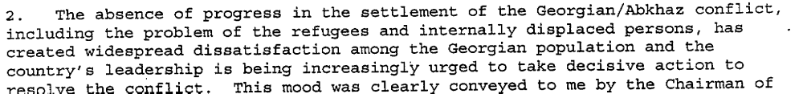
s/1997/340

Assessment

Short-term compliance
No or marginal compliance (1) | Medium low compliance (2) | Medium high compliance (3) | Full or almost full compliance (4)

Considerations underlying the assessment

Medium-term compliance

Description of the addressee(s)’ conduct

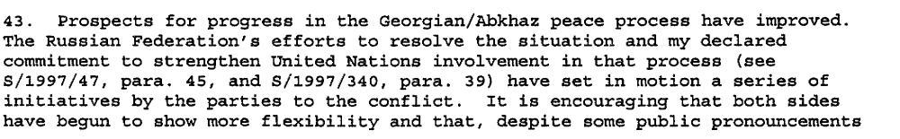s/1997/558

Assessment

Medium-term compliance
No or marginal compliance (1) | Medium low compliance (2) | Medium high compliance (3) | Full or almost full compliance (4)

Considerations underlying the assessment

Depth of demand

Assessment

Level of depth of demand
Low depth of demand (1) | Medium depth of demand (2) | High depth of demand (3)

Considerations underlying the assessment

Level of confidence about coding decisions
Level of confidence about coding decision
Extremely high | High | Moderate

Comments to IPI (if any)

Civil war in Georgia

UNSC Resolution: | 1096
Date of adoption: | 30-Jan-1997
Operative paragraph: | 7
Demand number: | 1096.0711

David Siroky

Wording of demand

intensify the search for a peaceful solution by further expanding the renewal of high-level direct dialogue

List of addressees of the demand

Government of Georgia, Abkhazia

Short-term compliance

Description of the addressee(s)’ conduct

s/1997/340

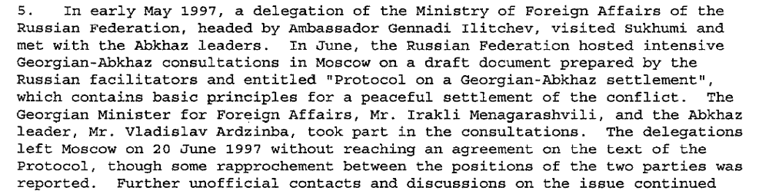s/1997/558

Assessment

Short-term compliance
No or marginal compliance (1) | Medium low compliance (2) | Medium high compliance (3) | Full or almost full compliance (4)

Considerations underlying the assessment

Medium-term compliance

Description of the addressee(s)’ conduct

s/1997/558

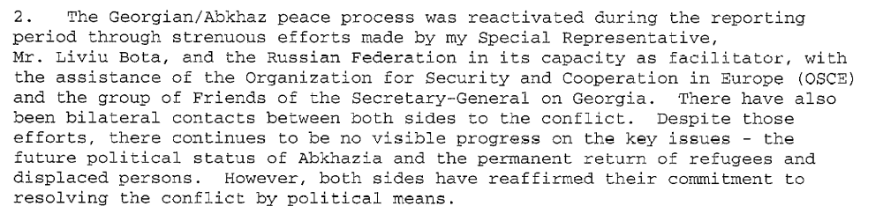
s/1997/827

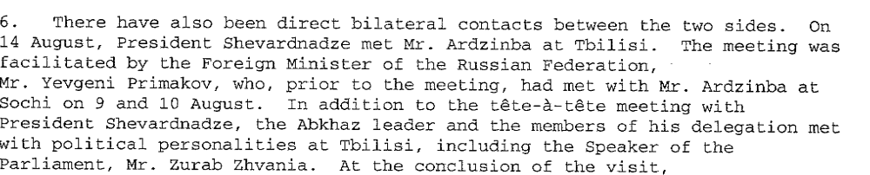

s/1997/827

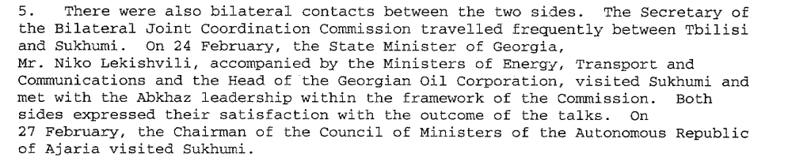

s/1998/375

Assessment

Medium-term compliance
No or marginal compliance (1) | Medium low compliance (2) | Medium high compliance (3) | Full or almost full compliance (4)

Considerations underlying the assessment

Depth of demand

Assessment

Level of depth of demand
Low depth of demand (1) | Medium depth of demand (2) | High depth of demand (3)

Considerations underlying the assessment

Level of confidence about coding decisions

Level of confidence about coding decision
Extremely high | High | Moderate

Comments to IPI (if any)

Civil war in Georgia

UNSC Resolution: | 1096
Date of adoption: | 30-Jan-1997
Operative paragraph: | 11
Demand number: | 1096.1111

David Siroky

Wording of demand

accelerate significantly the process of voluntary return of refugees and displaced persons without delay or preconditions, in particular by accepting a timetable on the basis of that proposed by the Office of the UN High Commissioner for Refugees and guarantee the safety of spontaneous returnees already in the area and regularize their status in cooperation with UNHCR and in accordance with the Quadripartite Agreement, in particular in the Gali Region

List of addressees of the demand

Abkhazia

Short-term compliance

Description of the addressee(s)’ conduct

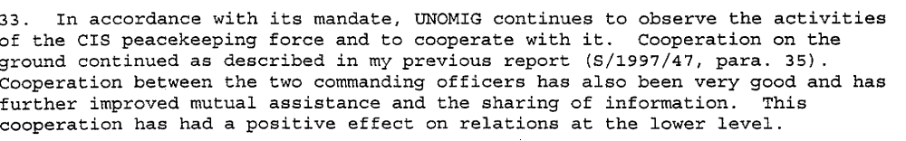s/1997/340

s/1997/558

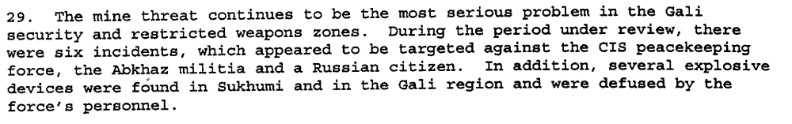
s/1997/558

Assessment

Short-term compliance
No or marginal compliance (1) | Medium low compliance (2) | Medium high compliance (3) | Full or almost full compliance (4)

Considerations underlying the assessment

Medium-term compliance

Description of the addressee(s)’ conduct

s/1998/375

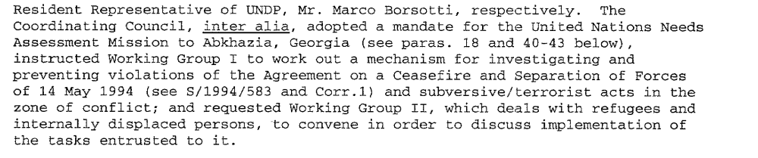s/1998/375

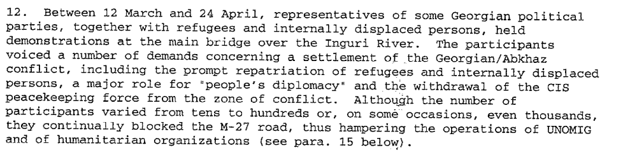s/1998/375

Assessment

Medium-term compliance
No or marginal compliance (1) | Medium low compliance (2) | Medium high compliance (3) | Full or almost full compliance (4)

Considerations underlying the assessment

Depth of demand

Assessment

Level of depth of demand
Low depth of demand (1) | Medium depth of demand (2) | High depth of demand (3)

Considerations underlying the assessment

Level of confidence about coding decisions

Level of confidence about coding decision
Extremely high | High | Moderate

Comments to IPI (if any)

Civil war in Georgia

UNSC Resolution: | 1096
Date of adoption: | 30-Jan-1997
Operative paragraph: | 12
Demand number: | 1096.1211

David Siroky

Wording of demand
continue negotiations of 23 and 24 December 1996 on the resumption of the orderly repatriation of refugees and displaced persons, in particular to the Gali Region

List of addressees of the demand

Government of Georgia, Abkhazia

Short-term compliance

Description of the addressee(s)’ conduct

s/1997/340

s/1997/558

s/1997/558
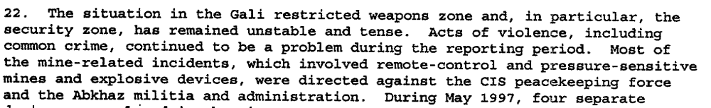
s/1997/558

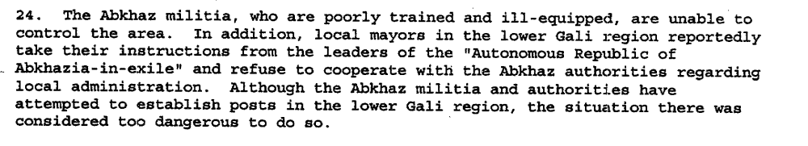s/1997/558

Assessment

Short-term compliance
No or marginal compliance (1) | Medium low compliance (2) | Medium high compliance (3) | Full or almost full compliance (4)

Considerations underlying the assessment

Medium-term compliance

Description of the addressee(s)’ conduct

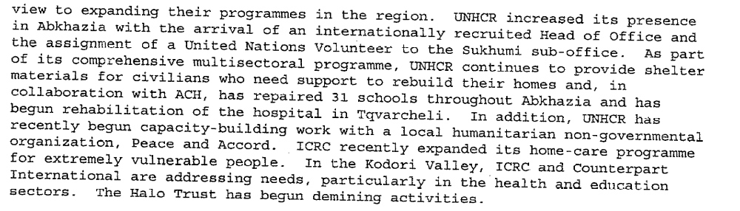
s/1998/51

s/1998/375

Assessment

Medium-term compliance
No or marginal compliance (1) | Medium low compliance (2) | Medium high compliance (3) | Full or almost full compliance (4)

Considerations underlying the assessment

Depth of demand

Assessment

Level of depth of demand
Low depth of demand (1) | Medium depth of demand (2) | High depth of demand (3)

Considerations underlying the assessment

Level of confidence about coding decisions

Level of confidence about coding decision
Extremely high | High | Moderate

Comments to IPI (if any)

Civil war in Georgia

UNSC Resolution: | 1096
Date of adoption: | 30-Jan-1997
Operative paragraph: | 13
Demand number: | 1096.1311

David Siroky

Wording of demand

ensure the full implementation of the Moscow Agreement [S/1994/583 Annex 1]

List of addressees of the demand

Government of Georgia, Abkhazia

Short-term compliance

Description of the addressee(s)’ conduct

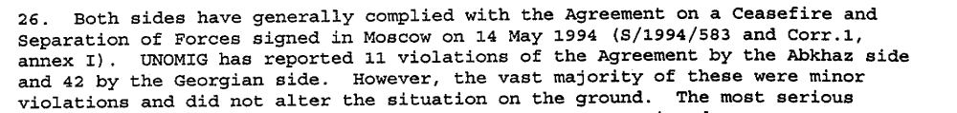s/1997/558

Assessment

Short-term compliance
No or marginal compliance (1) | Medium low compliance (2) | Medium high compliance (3) | Full or almost full compliance (4)

Considerations underlying the assessment

Medium-term compliance

Description of the addressee(s)’ conduct

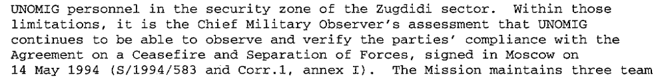
s/1997/827

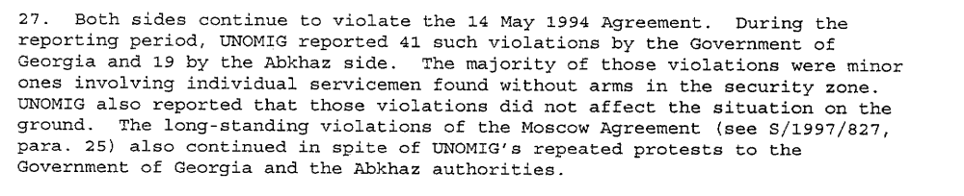
s/1998/51

Assessment

Medium-term compliance
No or marginal compliance (1) | Medium low compliance (2) | Medium high compliance (3) | Full or almost full compliance (4)

Considerations underlying the assessment

Depth of demand

Assessment

Level of depth of demand
Low depth of demand (1) | Medium depth of demand (2) | High depth of demand (3)

Considerations underlying the assessment

Level of confidence about coding decisions

Level of confidence about coding decision
Extremely high | High | Moderate

Comments to IPI (if any)

Civil war in Georgia

UNSC Resolution: | 1096
Date of adoption: | 30-Jan-1997
Operative paragraph: | 14
Demand number: | 1096.1411

David Siroky

Wording of demand

take all measures in their power to prevent mine laying and cooperate fully with UNOMIG and the CIS peace-keeping force in order to honour their commitments to ensure the safety and the freedom of movement of all personnel of the UN, the CIS peace-keeping force and international humanitarian organizations

List of addressees of the demand

Government of Georgia, Abkhazia

Short-term compliance

Description of the addressee(s)’ conduct

s/1997/340

s/1997/558

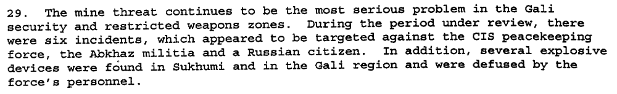

s/1997/558

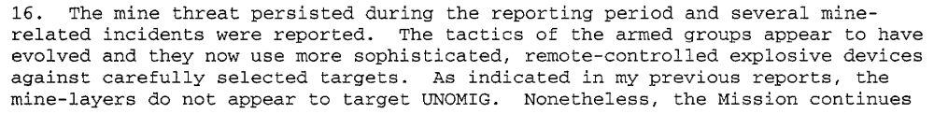s/1997/827

Assessment

Short-term compliance
No or marginal compliance (1) | Medium low compliance (2) | Medium high compliance (3) | Full or almost full compliance (4)

Considerations underlying the assessment

Medium-term compliance

Description of the addressee(s)’ conduct

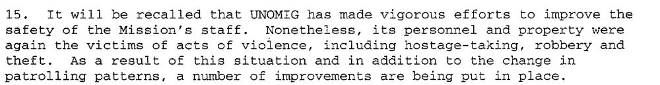s/1997/827

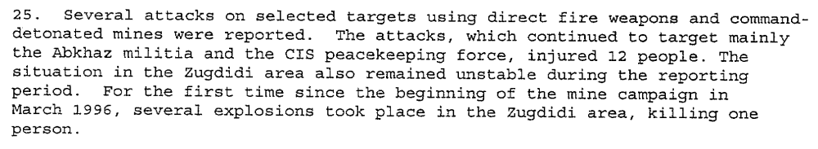
s/1998/51

Assessment

Medium-term compliance
No or marginal compliance (1) | Medium low compliance (2) | Medium high compliance (3) | Full or almost full compliance (4)

Considerations underlying the assessment

Depth of demand

Assessment

Level of depth of demand
Low depth of demand (1) | Medium depth of demand (2) | High depth of demand (3)

Considerations underlying the assessment

Level of confidence about coding decisions

Level of confidence about coding decision
Extremely high | High | Moderate

Comments to IPI (if any)

